JAN

10.

* I've spoken to Josh in Stamford -

SCOTT

* Yeah -

JAN

* I've told him the same as you. And it's up to either you or him to convince me that your branch could incorporate the other.

SCOTT

- Okay, no problem -

JAN

This does, however, mean that there is going to be downsizing.

SCOTT

Oh, you see,—me no want to hear that, Jan, because downsizing is a bitch. It is a real bitch. I wouldn't wish that on

Josh's men. I certainly wouldn't wish it on my men. Or women. Present company excepted. Is Josh concerned about downsizing?

JAN

Well he is, of course, yes.

SCOTT

Good. Because I'm very concerned about downsizing, although I understand if it's absolutely necessary, as a businessman, then it has to be... Does he understand if it's -

JAN

(stopping him)

* Michael -

SCOTT

* Go on -

JAN

- Can we not talk about downsizing? -

SCOTT

Well, we have to sooner or later -

JAN

11.

(stopping him)

- Yes, but at the moment, what we have to decide is, do you take on Stamford's people at this branch or the other way round?

SCOTT

We'll take on theirs.

|  |  |
| --- | --- |
| No - No? | JAN SCOTT |

JAN

* No, you and I don't decide. I decide.

SCOTT

You do decide, but -

JAN

I decide once you've made your case

SCOTT

* based on fac rs. Okay. Is there a time limit o ?

Scott's desk phone rings. His answer machine kicks in.

SCOTT

I'll just screen it.

SCOTT'S VOICE

Hi, I'm not available, so please leave a *massage.*

TODD PACKER

(on phone)

Alright, Mikey, it's the Packer. What's going on?

SCOTT

(showing off)

Todd Packer. Terrific rep.

TODD PACKER

I hear you've got a hangover, you big fag.

SCOTT

Oh, that's not good. That's derogatory.

TODD PACKER

Call me back. Hey, you're in with that Jan what's-her-face today, aren't you? Give her a pork from me, dude.

SCOTT

(embarrassed)

Oh... Awful, awful man.

JAN

Can we keep a lid on this for the time being? I really don't want to worry people unduly.

SCOTT

No worries. Under this regime, this will not leave the office.

He mimes zipping his mouth shut. As soon as he has said this we cut to a montage of different employees discussing the news.

**ANGLE ON DONNA**

DONNA

So what does downsizing actually mean?

**ANGLE ON EMMA AND KEVIN**

EMMA

So, you'd just go, would you?

KEVIN

Would you?

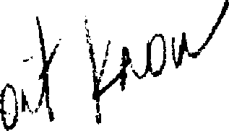

EMMA

Oh, I dunno. 1)

**ANGLE ON JIM AND PAM**

Jim is discussing things with Pam.

JIM

Kevin and Donna and all the others are having these -

PAM

Yeah, I know, they're all going nuts, aren't they?

JIM

- weird sort of secret pow-wows

PAM

I actually don't give (a monkeys, d,5 you?

ti

JIM

- "Oh, no, we're gonna lose our jobs." I

could care less.

Pam holds up her pinkie finger. Jim holds up his and they give a little pinkie finger shake on it. (Or some other tiny piece of ad-libbed flirtation.)

**PAM TALKING HEAD - INT**

PAM

I hope they do get rid of me... Because then I might actually get off my ass and do something. Um, I don't think it's many little girls' dream to be a

receptionist. I used to do illustrations. Mostly watercolor, a few oil pencils... Jim thinks they're good. Maybe they are... I just don't want to be treading water, you know, and then wake up in another five years and say, "shoot, done it again."

**SCENE 9 - INT. DESK AREA - DAY**

Dwight is sitting at his desk, playing with some chewing gum in his mouth. He notices the camera and puts the gum in the garbage as discreetly as possible. He goes back to his work.

**INT. RECEPTION AREA - DAY**

Pam is introducing Ryan, a young temp, to Scott.

PAM

This is Mr. Scott.

SCOTT

Guilty.

RYAN

Hey.

Scott gives a "Who are you?" expression.

RYAN

Ryan Howard, from the temping agency. Daniqua sent me down to start today.

14.

SCOTT

Just a temp... Howard? Like Moe Howard? Stooges, man.

With lighting wit, Scott snaps into an impersonation of The Three Stooges.

SCOTT

Nyuk, nyuk, nyuk! Moe! Gimme five. (off Pam's look)

It's a guy thing, Pam. Who was the one before Shemp?

RYAN

Curly?

SCOTT

Right. Curly Joe Dorita.

RYAN

Just Curly. 'doe Dorita's different.

SCOTT

Hey -- comedy's kind of my thing, so...

Here's Curly Joe:
  
(Curly voice)
  
Nyuk, nyuk, nyuk!

Ryan laughs politely.

**SCOTT TALKING HEAD - INT - DAY**

SCOTT

What upsets me about the job? Wasted talent. People could come to me, and they could say, "Excuse me, Michael, but you've been in the business twelve years. Can you tell us how to manage a team, how to keep them happy as well as moving towards the goal posts?" But they don't. That's the tragedy.

Scott shrugs as if it hurts to be a martyr, but he can take it.

**INT. DESK AREA - DAY**

Jim is on the phone. Some of Jim's possessions have slipped across onto Dwight's desk, and Dwight is pushing them back with a ruler. He slides it between his and Jim's desks to clarify just where the dividing line is. This is too much for Jim.

15.

JIM

Yeah... Look, Mr. Davis, I'm gonna have to call you back. Something's just come up. Two minutes. Thanks very much. Bye.

Jim puts down the phone.

JIM

(to Dwight)

What are you doing?

DWIGHT

What?

JIM

Dwight, what are you doing?

DWIGHT

I'm just pushing your stuff off my desk, I can't concentrate when...

JIM

It's not on your desk.

DWIGHT

It was, it's all overlapping. It's all coming over the edge here.

Jim buries his head in his hands.

DWIGHT

One word, two syllables: De-mar-cation.

**INT. OPEN-PLAN OFFICE - DAY**

Ryan is being led through the office by Michael Scott. Scott grins excitedly and points out a 'Homer Simpson' doll impaled on a coat stand. He waits for a big laugh. Ryan looks at him calmly. Unfazed, he continues.

SCOTT

This is the accounting department. The number dudes. Don't let the job descriptions fool ya. They are all completely crazy.

(pointing to Kevin)

Especially that one. He's a mental patient. Not literally, of course, that wouldn't work. The last place you'd want someone like that is in accounting...

16.

Scott crouches behind an office plant and peers through the leaves.

SCOTT

"Veddy interesting.... But shtoopid!" Artie Johnson. I do that to cheer 'em up. We send the girls out to get the plants. You know, it makes them a little bit happier, because they can sometimes get a little...

He mimes 'depressed.' Scott leans over to a novelty fish mounted on the wall and presses the button. Nothing happens.

SCOTT

Oh, the batteries are dead. C'mon people!

(to an employee)

Can you get some batteries for 'Billy

Bigmouth?' Take it out of petty cash.

(to camera crew)

You can't put a price on comedy.

**INT. DESK AREA - DAY**

JIM

You're a scrotum, Dwight. You're a scrotum and a dildo.

DWIGHT

I'm still not listening, so it's not offending me, so.

JIM

Right, okay, so you won't hear this - you're a tool, you're a tool, you're a tool.

Dwight ignores him.

JIM

You're a tool.

**DWIGHT TALKING HEAD - INT. - DAY**

DWIGHT

Yeah, it's okay here, but people

sometimes take advantage, because it's so relaxed. You know, I'm a volunteer Sheriff's Deputy on the weekends and you can't screw around there. That's sort of one of the rules.

**INT. OPEN-PLAN OFFICE - DAY**

17.

Shots of people working, then cut to: Ryan's induction is still underway. Scott points out a sketch pinned to a board.

SCOTT

Cartoons. "Does my butt look big in this?" Now, don't worry, that's not sexist,'cause the man is sayin it...finally! So, props for that... props for that in the workplace.

Dwight walks by, stirring a cup of coffee.

SCOTT

Ooh, careful, watch out for this guy! Dwight Schrute in the building!

(making the introductions)

Ryan, the new temp.

DWIGHT

Hey.

RYAN

Good to see you.

SCOTT

Introduce yourself.

DWIGHT

Uh... Dwight Schrute, Assistant Regional Manager.

SCOTT

Assistant *to* the Regional Manager.

Scott points to himself.

SCOTT

Dwight's my right-hand man, immediately beneath me.. as the priest said to the altar boy! Bill Maher. Not his line, but in the style of.

(Ryan stares at him.)

Of course, there's nothing wrong with that, if you're gay. I mean, not that I'm asking, I'm not allowed to ask if

you're gay... or Catholic. And if you're Catholic, well... it's actually word for word a Bill Maher line, so don't blame me. Over here is the kitchen...

**Scott steers Ryan into a little room with a coffee maker and accessories.**

**18.**

**SCOTT**

**We provide tea bags, sugar, stirrers, creamer, the works. Oh, coffee tax. I collect a coffee tax to pay for better coffee. Starbucks, man. Only the 'Bucks will do! So... How 'bout, fifty cents to start?**

**He holds his hand out. There is an uncomfortable pause.**

**SCOTT**

**(he half-glances to camera) It's usually more, but...**

**Finally, Ryan takes out some money and gives it to Scott. INT. DESK AREA - DAY**

**Jim is taping something. Dwight appears and demands his tape back by holding out his hand. Jim slaps it.**

**JIM**

**Hey soul brother.**

**DWIGHT Give it back.**

**JIM**

**I'm just using it for a second.**

**Dwight snatches the tape back. It has his name written on it in Wite-Out.**

**DWIGHT**

**It's got my name on it. 'Dwight.'**

**JIM**

**Uh, actually it says, 'Dwig,' but**

**DWIGHT**

**If you want to borrow it, just gotta ask.**

**JIM**

**Dude, you always say "no." What's the point?**

**DWIGHT**

**Maybe that's why you should ask.**

19.

JIM

Dwight, it was just there, okay?

DWIGHT

Yeah? That's its home. Leave it there.

Dwight puts the tape dispenser back in its proper place.

JIM

Okay... Okay... Okay...

Driven to desperate measures, Jim snatches the tape dispenser and runs to the window.

DWIGHT

(panicked)

Somebody stop him! Dammit, that's mine!

Jim holds the tape dispenser out of the window.

JIM

You stay where you are, okay? I'm gonna let this go, okay, unless you stop acting like a tool.

DWIGHT

Yeah, like you

JIM

Yeah, like I did...

Jim lets go of the tape dispenser.

DWIGHT
  
What if that kills someone?

JIM

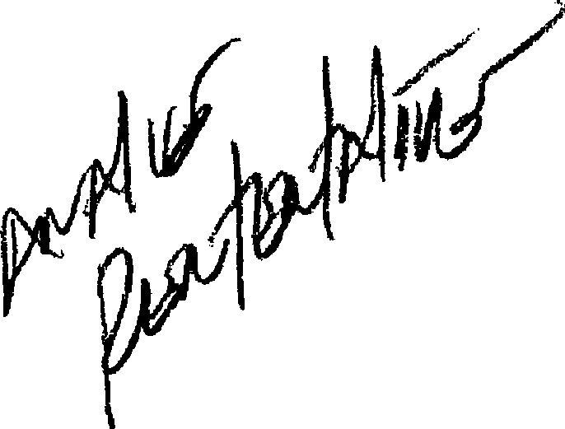Kills somebody? * Umm, well, they'll think you're the murderer. It's got your name on it.

DWIGHT

Why would a murderer put his name on the murder weapon?

JIM

Because he's an impossib annoying prick?

DWIGHT (calling)

Michael!